生产网拓扑图
Production network topology diagram

生产网络安全等级
- 一级区域（外部互联网）Level 1 – External Internet (Public Zone)
即不可信网络边界，包括公共互联网及任何未受控的外部网络环境。该区域被视为高威胁来源，所有进出流量均需经过严格访问控制与威胁检测。
An untrusted network boundary, including the public internet and any uncontrolled external network environments. This zone is considered a high threat source. All inbound and outbound traffic must undergo strict access control and threat inspection.

- 二级区域（对外服务缓冲区，DMZ）Level 2 – External Service Buffer Zone (DMZ)
位于内部网络与外部互联网之间的隔离层，用于部署需对外提供服务的系统（如映射的 SFTP、Web 服务器、邮件中继等）。该区域禁止直接发起对内部可信网络（三级及以上）的访问，仅允许必要的业务数据流进入，并严格限制出入方向的服务协议与端口。
An isolation layer located between the internal network and the external internet, used to deploy systems that need to provide external services (e.g., mapped SFTP, web servers, mail relays). This zone is prohibited from directly initiating access to the internal trusted network (Level 3 and above). Only necessary business data flows are allowed to enter, and service protocols and ports in both directions are strictly restricted.

- 三级区域（IT 基础架构区域）Level 3 – IT Infrastructure Zone
承载企业核心 IT 基础服务（如身份认证、补丁管理、日志采集、终端管理、DNS、DHCP 等）的区域。该区域具备有限的互联网访问能力（如下载补丁、更新病毒库），但入向访问需经明确授权与安全检测，且与二级区域之间采用防火墙或路由策略进行隔离。
A zone that hosts core enterprise IT infrastructure services (e.g., identity authentication, patch management, log collection, endpoint management, DNS, DHCP). This zone has limited internet access capability (e.g., for downloading patches, updating antivirus signatures). However, inbound access must be explicitly authorized and subject to security inspection. Isolation from Level 2 is enforced through firewalls or routing policies.

- 四级区域（门禁与 CCTV 区域）Level 4 – Access Control & CCTV Zone
用于部署物理安防系统（门禁控制器、视频监控设备、存储服务器等）的专用区域。该区域严格禁止访问互联网，仅允许在内部管理网络中进行访问控制与视频调阅，通常采用物理隔离方式，并限制与三级区域之间的通信为仅必要的管理流量。
A dedicated zone used to deploy physical security systems (e.g., access controllers, video surveillance devices, storage servers). This zone strictly prohibits internet access. Only access control and video retrieval are permitted within the internal management network. Physical isolation is typically adopted, and communications with Level 3 are restricted to only necessary management traffic.

- 五级区域（高安全区域）Level 5 – High Security Zone
部署于双重防火墙架构之后的最高安全等级区，用于托管关键业务系统、核心数据库、密钥管理系统或敏感数据资产。该区域遵循最小权限与默认拒绝原则，所有流量必须依次经过两道防火墙的访问策略检查，同时禁止任何形式的互联网直接访问。
The highest security level zone, deployed behind a dual-firewall architecture, used to host critical business systems, core databases, key management systems, or sensitive data assets. This zone follows the principle of least privilege and default deny. All traffic must sequentially pass through access policy inspections of both firewalls. Any form of direct internet access is strictly prohibited.

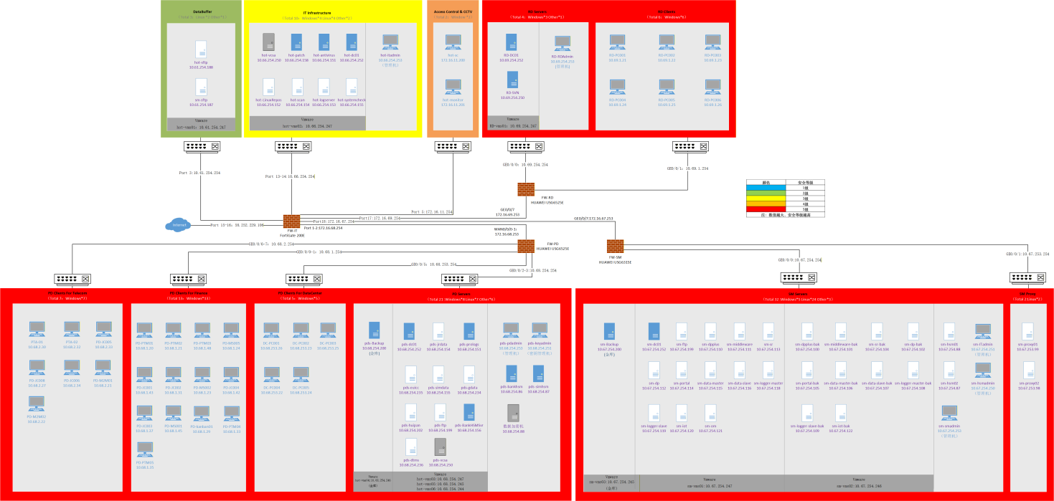

办公网拓补图
Office network topology diagram
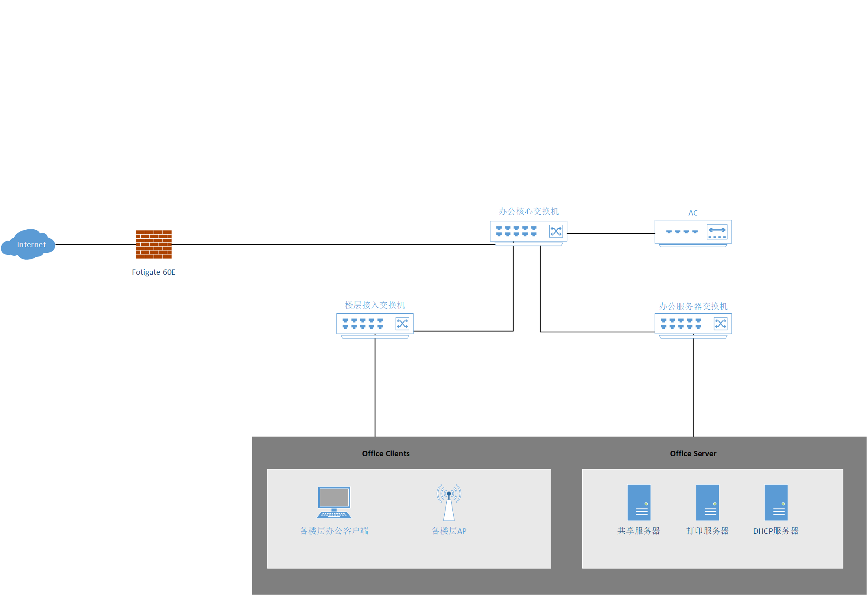

Document History 文件历史记录

版本  Version | 日期  Date | 变更简述  Brief Description of change | 编辑  Editor | 审批  Auditor | 批准  Approve
1.0 | 2025/1/15 | 新版发布  New version release | 郑炳佳 | 杨龙威 | 郭思才
2.0 | 2025/4/30 | 修改信息等级  Modify information Class | 郑炳佳 | 杨龙威 | 郭思才
3.0 | 2025/5/10 | 添加色块区分安全等级  Add color blocks to distinguish security levels | 郑炳佳 | 杨龙威 | 郭思才
4.0 | 2025/5/23 | 增加目视化管理  Increase visual management | 郑炳佳 | 杨龙威 | 郭思才
5.0 | 2025/5/26 | 增加交换机标识  Add Switch identification | 郑炳佳 | 杨龙威 | 郭思才
6.0 | 2025/7/10 | 新增SM网络  Add a new SM network | 郑炳佳 | 杨龙威 | 郭思才
7.0 | 2025/12/25 | 调整安全等级  Adjust the security level | 郑炳佳 | 杨龙威 | 郭思才
8.0 | 2026/5/10 | 生产网安全等级描述  Description of the production network security level | 郑炳佳 | 杨龙威 | 郭思才

编制：  Editor: | 审批：  Auditor: | 批准：  Approve:

